Project Report

Final Milestone

CMPE 256: Large Scale Analytics  
San Jose State University  
Master of Science in Data Analytics



**Group 8**

Aarathi Nadathur – 013704405  
Amar Ippili- 013728975

Divya Puraswani - 013755391

Sai Chaitanya Tolem - 013008788

Sameer Rajput - 013802841

Shubh Johri – 013750672

Link: Google Colaboratory:

Milestone 1:

<https://colab.research.google.com/drive/1O9_PPjahcNxsW--I9ryDNzyWu_G4pSZi>

Milestone 2: <https://colab.research.google.com/drive/16TtXoGW9QJXmv5EpXMTbUyrWIyUNVLCC>

Naïve Bayes 25 Trials: sklearn

<https://colab.research.google.com/drive/1ue7JbO_ue0vtRXudnso7SpY_SdNsfAfk>

Random Forest 25 Trials: sklearn <https://drive.google.com/file/d/0ByovCDc4ECL-YVBQVjFwV0wwU2FWaEk4U3M0eTJTRlVLa1dF>

**Who Did What!**

|  |  |  |
| --- | --- | --- |
| **Milestone 2(Final)** | | |
| **What** | **Description** | **Who** |
| Technical | 1. Overview of selected and additional algorithm- RandomForest | Sai Chaitanya, Divya Puraswani, Sameer Rajput |
| 1. Overview of additional algorithm - Naïve Bayes | Shubh Johri, Amar Ippili, Aarathi Nadathur |
| 1. Data Preparation and EDA | Sai Chaitanya, Sameer Rajput, Divya Puraswani |
|  | 1. Data Validation, Data Preprocessing | Shubh Johri, Aarathi Nadathur, Amar Ippili |
| Presentation | 1. PowerPoint Preparation | Entire Team |
| 1. In Class PowerPoint Presentation | Entire Team |
| Documentation | 1. Report Preparation | Shubh Johri, Aarathi Nadathur, Divya Puraswani |
| 1. Report Editing | Sai Chaitanya, Sameer Rajput, Amar Ippili |

|  |  |  |
| --- | --- | --- |
| **Milestone 1** | | |
| **What** | **Description** | **Who** |
| Technical | 1. Overview of selected and additional algorithm | Sai Chaitanya, Divya Puraswani, Sameer Rajput |
| 1. Data Preparation and EDA | Sai Chaitanya, Sameer Rajput |
| 1. Data Validation, Data Preprocessing | Shubh Johri, Aarathi Nadathur, Amar Ippili |
| Presentation | 1. PowerPoint Preparation | Aarathi Nadathur, Divya Puraswani, Shubh Johri |
| 1. In Class PowerPoint Presentation | Entire Team |
| Documentation | 1. Report Preparation | Shubh Johri, Aarathi Nadathur, Divya Puraswani |
| 1. Report Editing | Sai Chaitanya, Sameer Rajput, Amar Ippili |

Contents

1. About the dataset 7

2. Problem 8

3. Software and libraries 8

**3.1 Google Colaboratory Environment** 8

4. Data Preparation 9

5. Data Filtration 10

6. Data Validation 11

7. Major differences between Spark and Scikit-learn 11

8. Machine Learning Algorithm 13

**8.1 RandomForestClassifier in PySpark** 15

**8.2** **Naïve Bayes in PySpark** 15

**8.3** **Model Architecture** 16

**8.4** **Model Performance** 16

9. The output images 28

10. Descriptive Statistics 29

**10.1 RandomForest** 30

**10.2 Naïve Bayes** 30

11. Model Comparison 31

12. Additional Experiments 35

**10.1 Normalizing** 35

**10.3 Gray scaling** 36

13. Conclusion 36

14. Lessons Learned 37

References 38

**Table of Figures**

Figure 1: Data Preparation 9

Figure 2: Milestone1- Data Filtration 10

Figure 3: Milestone 2- Data Filtration 10

Figure 4: Data Validation 11

Figure 5: Random Forest Architecture 16

Figure 6: Naïve Bayes Architecture 17

Figure 7: Accuracies- Milestone 1 17

Figure 8: Confusion matrix- RandomForest- SKLearn 18

Figure 9: Classification report- RandomForest- SkLearn 18

Figure 10: Confusion Matrix- RandomForest-PySpark 18

Figure 11: Classification Report- RandomForest- PySpark 19

Figure 12: Confusion Matrix-Naïve Bayes-SkLearn 19

Figure 13: Classification Report- Naïve Bayes- SkLearn 20

Figure 14: Confusion Matrix- Naive Bayes- PySpark 20

Figure 15: Classification Report- Naive Bayes- PySpark 20

Figure 16: Milestone 2- Accuracies 21

Figure 17: Confusion Matrix- RandomForest-SkLearn 21

Figure 18: Classification Report- RandomForest- SkLearn 21

Figure 19: Confusion Matric- Random Forest 22

Figure 20: Classification Report- Random Forest 22

Figure 21: Pairs and their accuracies- RandomForest- Scikit Learn 22

Figure 22: Pairs and their accuracies- Random Forest PySpark 23

Figure 23: Confusion Matrix-Naïve Bayes- SKLearn 24

Figure 24: Classification Report- Naïve Bayes- SKLearn 24

Figure 25: Confusion Matrix- Naïve Bayes-Pyspark 24

Figure 26: Classification report- Naïve Bayes-Pyspark 24

Figure 27: Pairs and accuracies- Naïve Bayes- SKLearn 25

Figure 28: Pairs and accuracies- Naïve Bayes-Pyspark 25

Figure 29: Matrix with accuracies-RandomForest 26

Figure 30: Milestone 2- Matrix with accuracies- Naïve Bayes 26

Figure 31: Matrix with fitting time – RandomForest 27

Figure 32: Matrix with fitting time- Naïve Bayes 27

Figure 33: Matrix with prediction time- Random Forest 27

Figure 34: Matrix with prediction time- Naïve Bayes 28

Figure 35: Output Images- Milestone 1 28

Figure 36: Output Images- Milestone 2 29

Figure 37- Descriptive Stats- RandomForest- SKLearn 29

Figure 38: Descriptive Stats- Random Forest- Pyspark 30

Figure 39: Descriptive Stats- Naïve Bayes- SkLearn 30

Figure 40: Descriptive Stats- Naïve Bayes- Pyspark 31

Figure 41: PySpark vs SkLearn- Fitting time – RandomForest 34

Figure 42: PySpark vs SkLearn-Fitting Time- Naïve Bayes 34

Figure 43: Prediction Time Comparison- RandomForest 35

Figure 44: Prediction time Comparison- Naïve bayes 35

Figure 45: Gray scaling 36

**List of Tables**

Table 1: Dataset Features 8

Table 2: Scikit vs PySpark 12

Table 3: Machine Learning algorithms- Accuracies 13

Table 4: Algorithms time taken 14

Table 5: ScikitLearn training time comparison 31

Table 6: PySpark training time comparison 32

Table 7: Scikitlearn prediction time comparison 33

Table 8: PySpark prediction time comparison 34

## **About the dataset**

The CIFAR-100 dataset has 100 classes containing 600 images each. There are 500 training images and 100 testing images per class. The 100 classes in the CIFAR-100 are grouped into 20 super classes. Each image comes with a "fine" label (the class to which it belongs) and a "coarse" label (the superclass to which it belongs) [1].

|  |  |
| --- | --- |
| **Super Class** | **Class** |
| Vehicle 1 | Bicycle, Bus, Motorcycle, Pickup truck, Train |
| Vehicle 2 | Rocket, Tank, Tractor, Streetcar, Lawnmower |

Table 1: Dataset Features

## **Problem**

**Milestone 1:**

Our goal is to perform a binary classification of images in vehicle 1 and vehicle 2 superclass pairs using PySpark and understand the difference between using scikit-learn and SparkML while working on the dataset.

**Milestone 2:**

The main goal of this project is to perform binary classification of images in two assigned superclass pairs given to your group and see if Spark is performing better than Scikit-learn. The robustness of the algorithm is tested against the hidden sub-class image data during the training stage.

## **Software and libraries**

### **3.1 Google Colaboratory Environment**

Google colaboratory environment is based on Python Jupyter notebooks which gives the user free access to Tesla K80 GPUs. It provides the ability to experiment with deep learning. To access the environment, you must have a signed in Google Drive account. The .ipynb files that you create will be saved in your Google Drive account. We have signed in using SJSU Email Id to access the environment and work with cifar100 dataset.[2]Apache Spark is a real time processing framework to analyze data in real time. To use it with Python, PySpark uses Resilient Distributed Dataset.

## **Data Preparation**

**Milestone 1 and 2**

Cifar 100 dataset consists of train, test and meta data. We loaded them into colaboratory and combined the images(X), coarse labels(Y) (0-19) data into data frame and filtered this data frame on target variable (vehicle1 =18, vehicle2 = 19) in scikit learn.

In pySpark, the train and test data are zipped separately and a parallelized collection(RDD) is created. Then the train and the test data are combined using the union method and converted into a Spark Dataframe.

**SCIKIT LEARN PYSPARK**

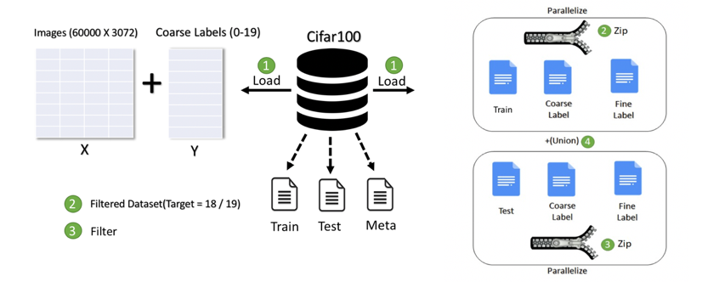

Figure 1: Data Preparation

## **Data Filtration**

**Milestone 1**

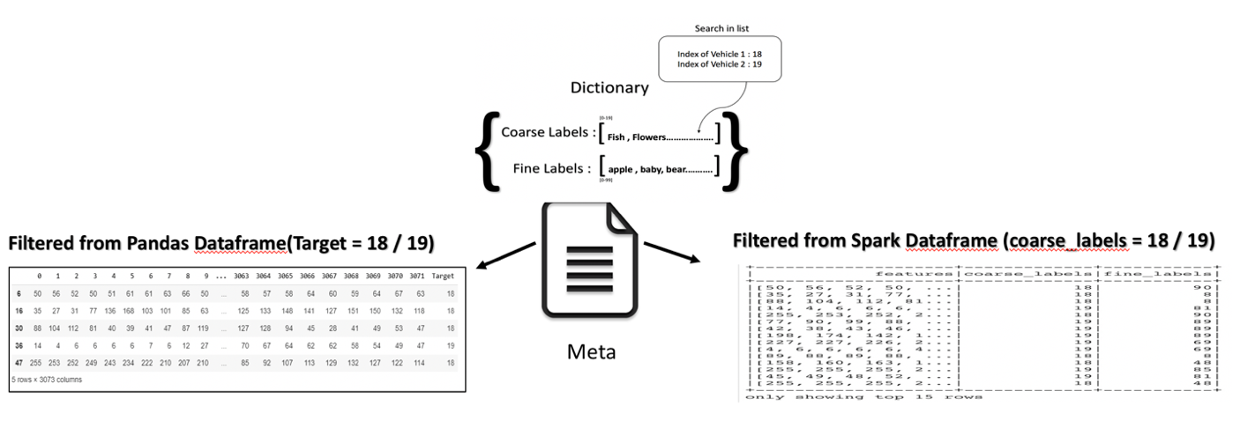

Figure 2: Milestone1- Data Filtration

We used the meta data file in cifar 100 which consists of a serialized dictionary object to search for index of vehicle 1, vehicle 2 in the coarse label list as in Figure 2 and validated that 18 corresponds to vehicle 1 and 19 corresponds to vehicle 2 through code and we have crosschecked it by plotting few images from the filtered dataset.

**Milestone 2**

Selection Of two Selected Sub- Classes as Testing Data:

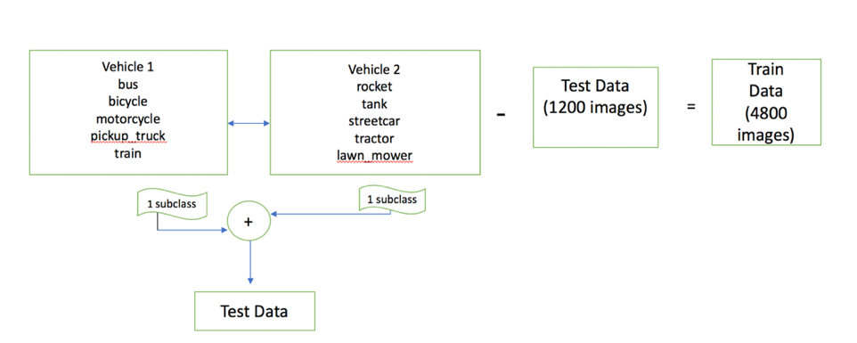

Figure 3: Milestone 2- Data Filtration

## **Data Validation**

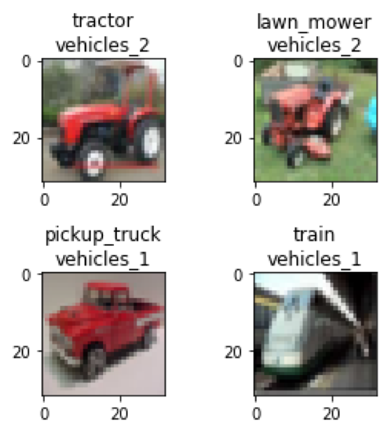

Figure 4: Data Validation

## **Major differences between Spark and Scikit-learn**

|  |  |  |
| --- | --- | --- |
| Parameters | Scikit-learn | SparkML |
| Dataset | It is not designed for handling huge datasets i.e. distributed computing on big data. | It can handle huge datasets i.e big data(hundreds of millions of records and more). Good for ETL and data transformations. |
| Language Supports/APIs | It is supported/can be implemented only in Python. | It can be implemented using Java, Scala and Python. |
| Parameters offered by RandomForest algorithm. | It offers several parameters to be tuned for increasing accuracy/performance.n_estimators is used for number of trees in the forest. | It considers numTrees (for number of trees in the forest parameter  for performance tuning and offers a smaller number of parameters as compared to  scikit-learn making easy for user to use. [3] |
| Library | from sklearn.ensemble import RandomForestClassifier | from pyspark.mllib.tree import RandomForest, RandomForestModelfrom pyspark.mllib.util import MLUtils . |
| Type of data/abstraction | It is in the form of array. | It is in the RDD<vector> form. |
| Input data | Pandas dataframe Each feature is a column | Spark dataframe  All features should be in one column |

Table 2: Scikit vs PySpark

## **Machine Learning Algorithm**

We ran different other models on the dataset to predict the accuracy and the following results were obtained:

|  |  |  |
| --- | --- | --- |
| **Algorithm** | **Accuracy Achieved(PySpark)** | **Accuracy Achieved(Scikit Learn)** |
| Logistic Regression | 64.2% | 60.08% |
| Decision Tree Classifier | 56.6% | 58.16% |
| Naive Bayes | 59.3% | 55.83% |
| Random Forest | 69.83% | 64.5% |

Table 3: Machine Learning algorithms- Accuracies

|  |  |  |
| --- | --- | --- |
| **Algorithm** | **CPU time/Wall time (PySpark)** | **CPU Time/Wall time (Scikit Learn)** |
| Logistic Regression | CPU Time:97.7 ms  Wall time: 1 mins 24 seconds | CPU time: 31.3 sec  Wall time: 31.4 sec |
| Decision Tree Classifier | CPU Time:93.1 ms  Wall time: 5 mins 44 seconds | CPU Time:19.4 sec  Wall time: 19.5 sec |
| Naive Bayes | CPU Time:40.3 ms  Wall time: 1 mins 18 seconds | CPU time: 223 sec  Wall time: 235 ms |
| Random Forest | CPU Time: 37sec  Wall Time: | CPU time: 79.9ms  Wall Time: |

Table 4: Algorithms time taken

From table 4 and 5 its seen that randomforest algorithm has highest accuracy than other algorithms. So, we chose random forest as the model and predicted the results. Apart from that we also predicted the results using Naïve Bayes algorithm.

### **8.1 RandomForestClassifier in PySpark**

* RandomForestClassifier is one of the most successful ensemble machine learning technique used for solving supervised problems of regression and classification. [4]
* It helps in reducing overfitting by combining several decision trees.
* The training process is done parallelly considering each of decision trees separately introducing randomness and uniqueness.
* The most important parameters for performance tuning are: numTrees and maxDepth which are used in our model.
* To measure the accuracy of algorithm test error is calculated. [5]

### **Naïve Bayes in PySpark**

* Naive Bayes is most widely used multi class classification algorithm. It computes the conditional probability distribution of each feature during a single pass of training data.
* The Algorithm uses the Bayes theorem for computing the conditional probability.
* The algorithm takes an RDD of LabeledPoint and  lambda ( smoothing parameter)as input, and output a NaiveBayesModel, which can be used for evaluation and prediction.
* In MLlib, multinomial naive Bayes and Bernoulli naive Bayes can be used. [6]
* For multiple features we use Multinomial NB. So, for our dataset we have used multinomial NB.

### **Model Architecture**

1. **RandomForest**

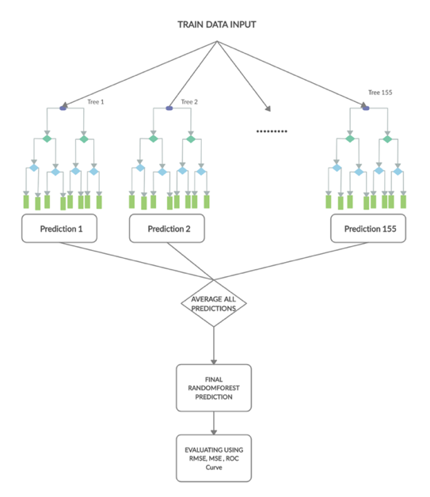

Figure 5: Random Forest Architecture

1. **Naïve Bayes**

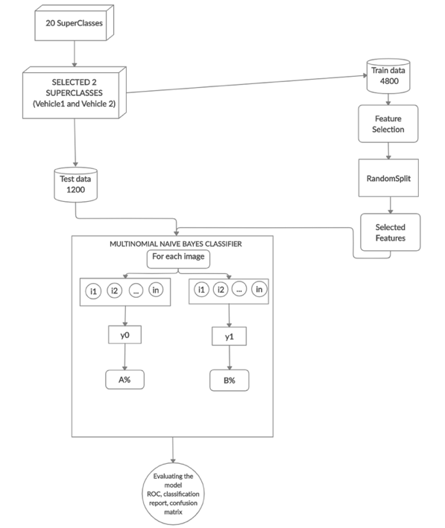

Figure 6: Naïve Bayes Architecture

### **Model Performance**

**Milestone 1**

1. **RandomForest**

Using the randomForest algorithm with random-split ratio: 80:20 , numTrees as 155 ; we got an accuracy of 64.5%. The etime taken for this model was 2min 35sec.

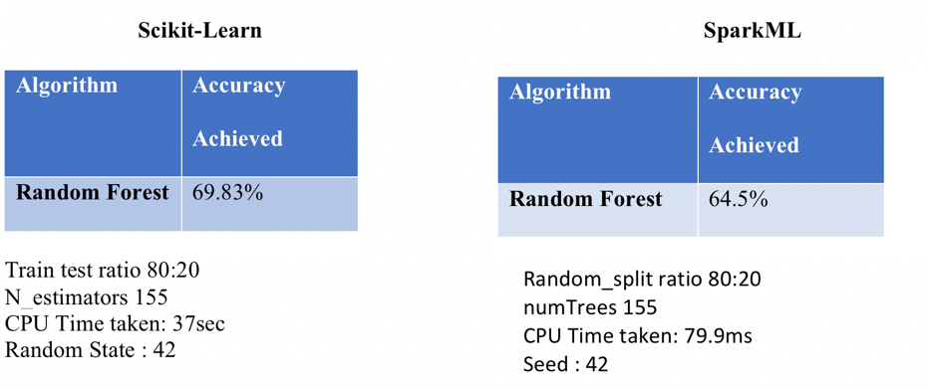

Figure 7: Accuracies- Milestone 1

**Evaluation Metrics**

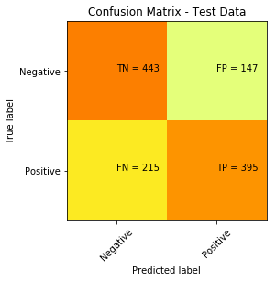

Figure 8: Confusion matrix- RandomForest- Sklearn

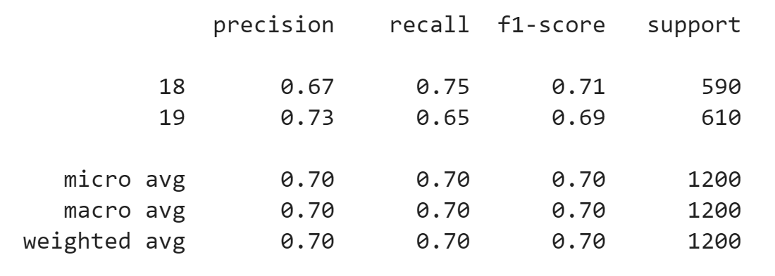

Figure 9: Classification report- RandomForest- Sklearn

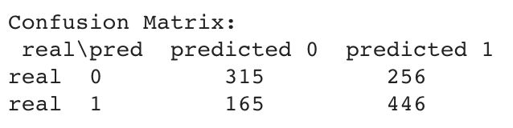

Figure 10: Confusion Matrix- RandomForest-PySpark

**Where: Predicted 0 is vehicle 1**

**Predicted 1 is vehicle 2**

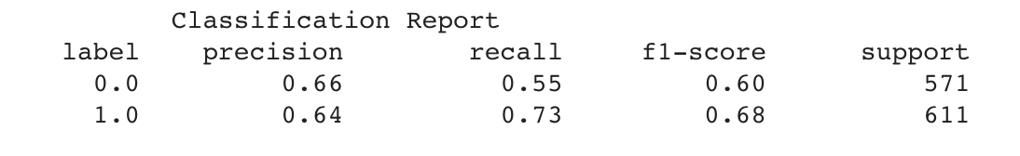

Figure 11: Classification Report- RandomForest- PySpark

**Where: Label 0.0 is vehicle 1**

**Label 1.0 is vehicle 2**

1. **Naïve Bayes**

**Sklearn PySpark**

|  |  |
| --- | --- |
| Algorithm | Accuracy Achieved |
| Naïve Bayes | 55.83% |

|  |  |
| --- | --- |
| Algorithm | Accuracy Achieved |
| Naïve Bayes | 59.3% |

**Evaluation Metrics**

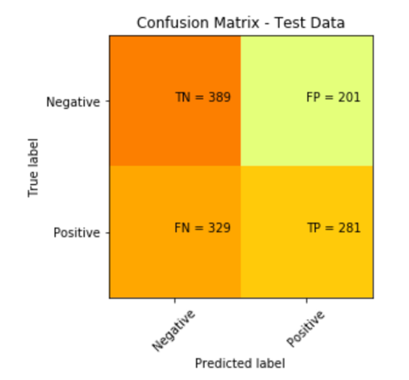

Figure 12: Confusion Matrix-Naïve Bayes-Sklearn

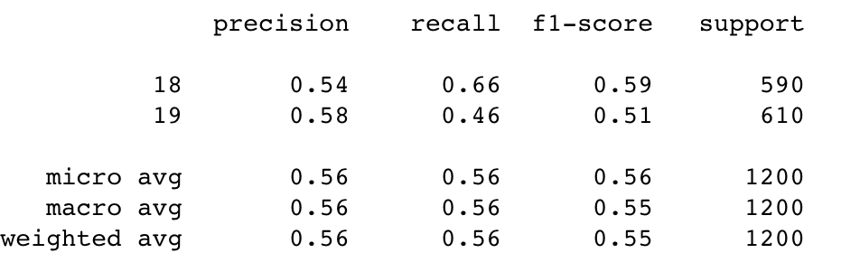

Figure 13: Classification Report- Naïve Bayes- Sklearn

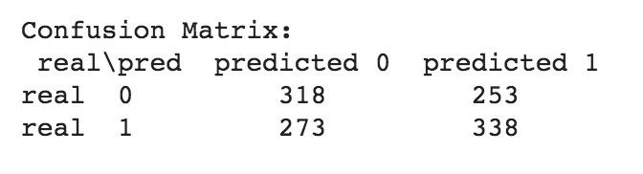

Figure 14: Confusion Matrix- Naive Bayes- PySpark

**Where: Predicted 0 is vehicle 1**

**Predicted 1 is vehicle 2**

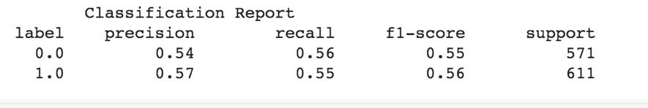

Figure 15: Classification Report- Naive Bayes- PySpark

**Where: Label 0.0 is vehicle 1**

**Label 1.0 is vehicle 2**

**Milestone 2**

We have selected motorcycle from vehicle1 and lawn_mower from vehicle2 as they closely resemble cycle, streetcar of vehicle 1, vehicle 2 respectively and our RandomForest model should be able to classify them easily even though motorcycle, lawn_mower is not present in the training dataset.

1. **RandomForest**

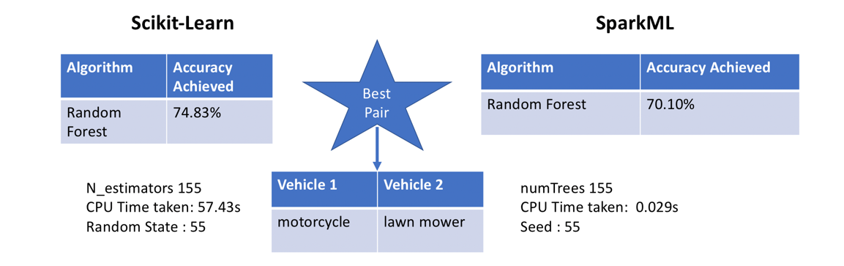

Figure 16: Milestone 2- Accuracies

**Evaluation Metrics**

**Scikit Learn**

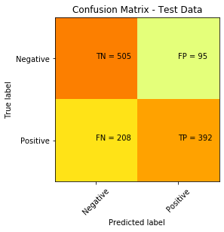

Figure 17: Confusion Matrix- RandomForest-Sklearn

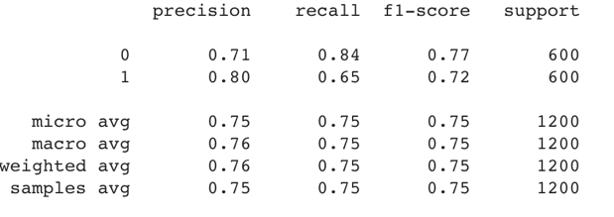

Figure 18: Classification Report- RandomForest- Sklearn

**PySpark**



Figure 19: Confusion Matric- Random Forest

**Where: Predicted 0 is vehicle 1**

**Predicted 1 is vehicle 2**



Figure 20: Classification Report- Random Forest

**Where: Label 0.0 is vehicle 1**

**Label 1.0 is vehicle 2**

**25 Pairs Accuracies**

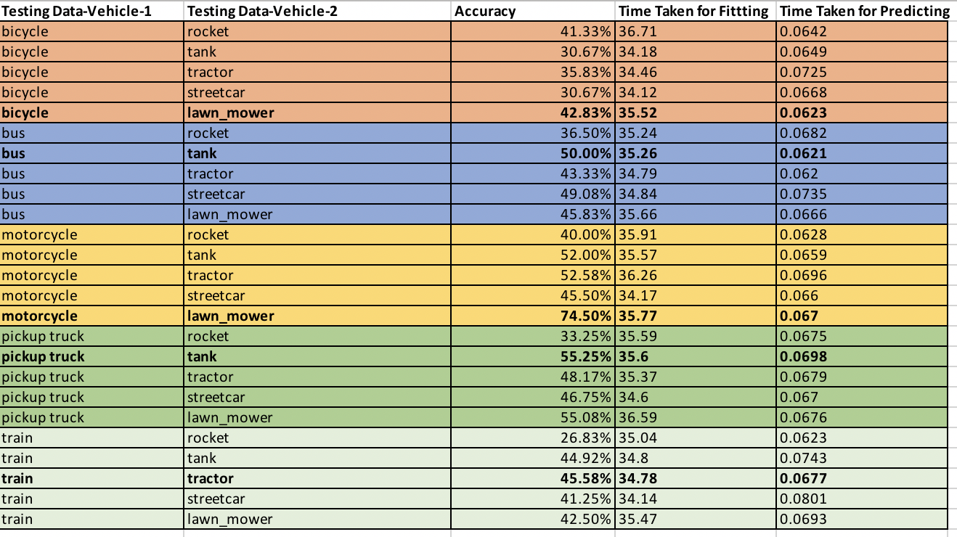

Figure 21: Pairs and their accuracies- RandomForest- Scikit Learn

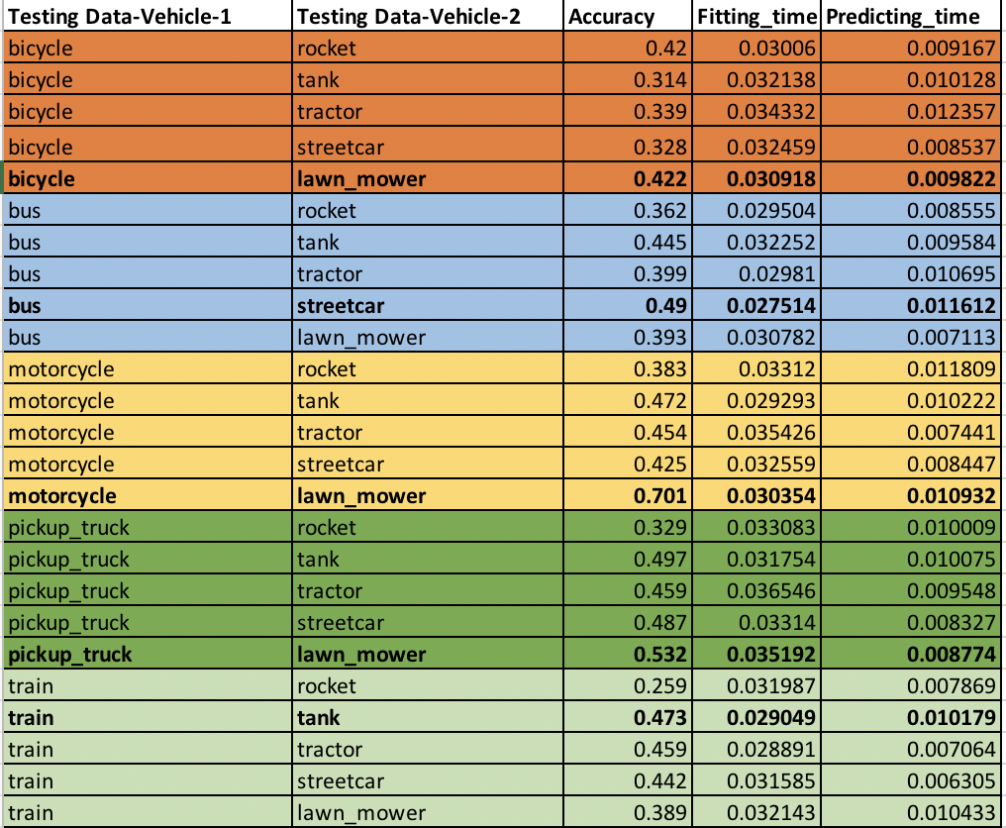

Figure 22: Pairs and their accuracies- Random Forest PySpark

1. **Naïve Bayes**

**Sklearn PySpark**

|  |  |
| --- | --- |
| Algorithm | Accuracy  Achieved |
| Naïve Bayes | **58.83** |

|  |  |
| --- | --- |
| Algorithm | Accuracy Achieved |
| Naïve Bayes | **58.8** |

**Evaluation Metrics**

**Scikit Learn**

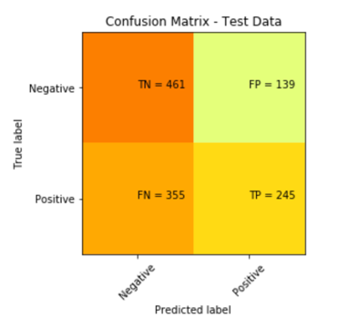

Figure 23: Confusion Matrix-Naïve Bayes- Sklearn

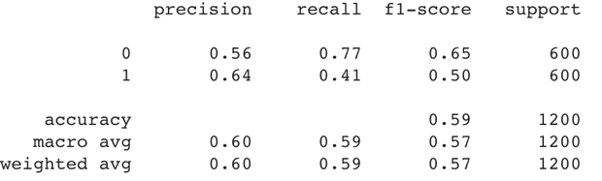

Figure 24: Classification Report- Naïve Bayes- Sklearn

**PySpark**

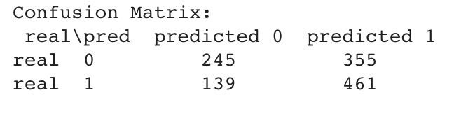

Figure 25: Confusion Matrix- Naïve Bayes-Pyspark

**Where: Predicted 0 is vehicle 1**

**Predicted 1 is vehicle 2**

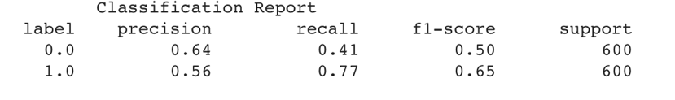

Figure 26: Classification report- Naïve Bayes-Pyspark

**Where: Label 0.0 is vehicle 1**

**Label 1.0 is vehicle 2**

**25 Pairs/Trials**

**Scikit Learn**

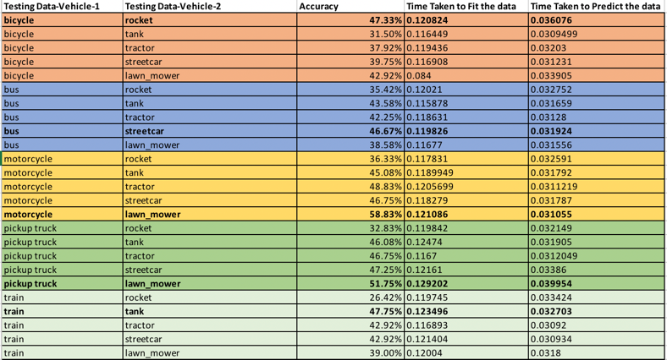

Figure 27: Pairs and accuracies- Naïve Bayes- Sklearn

**PySpark**

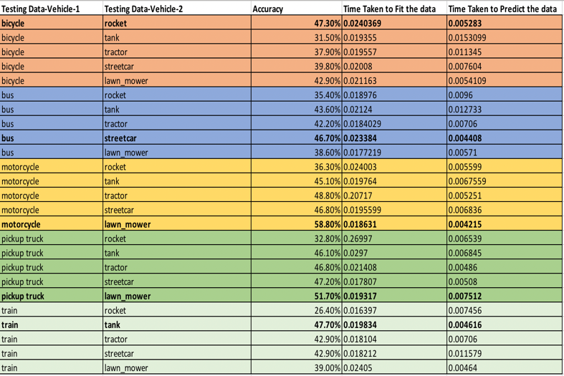

Figure 28: Pairs and accuracies- Naïve Bayes-Pyspark

**Selected Pairs**

Form the matrices shown below we can see that in both pySpark and Sklearn the top 5 and bottom 5 accuracies are almost same, with lawnmower and motorcycle pair having the highest accuracy. The main difference between pySpark and Sklearn was the time taken. **PySpark is nearly 1000 times faster than Sklearn.**

**Accuracy**

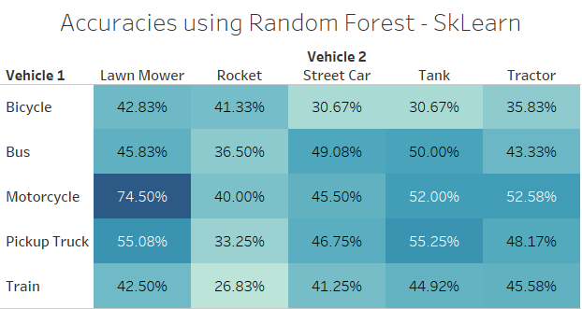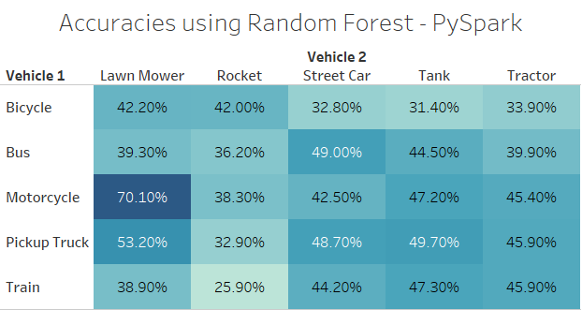

Figure 29: Matrix with accuracies-RandomForest

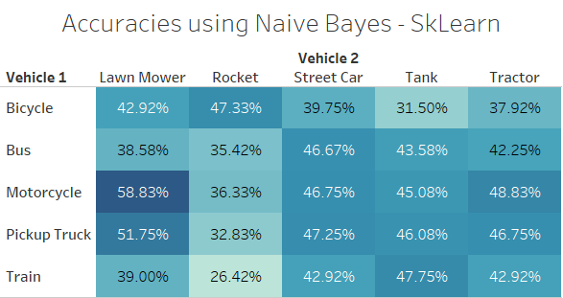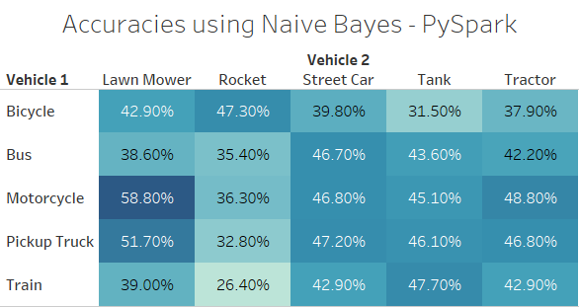

Figure 30: Milestone 2- Matrix with accuracies- Naïve Bayes

**Fitting Time**

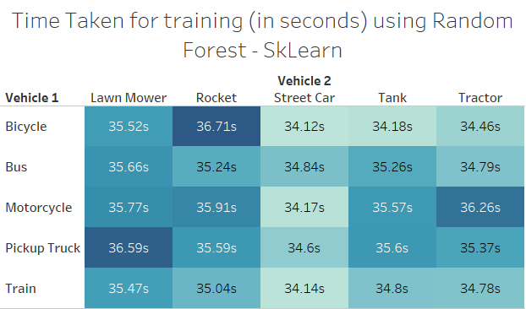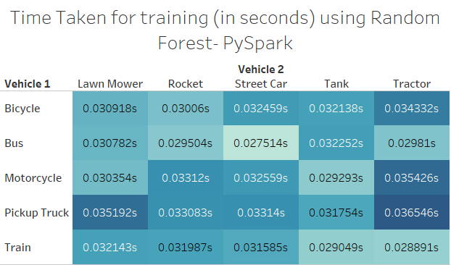

Figure 31: Matrix with fitting time – RandomForest

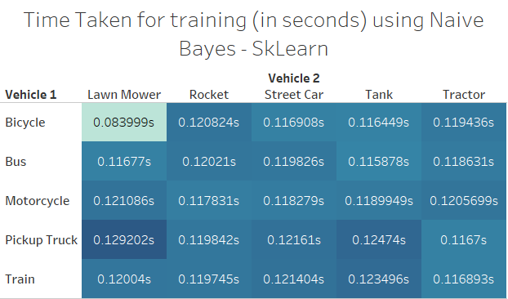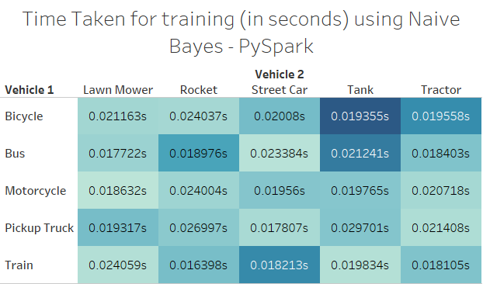

Figure 32: Matrix with fitting time- Naïve Bayes

**Prediction Time**

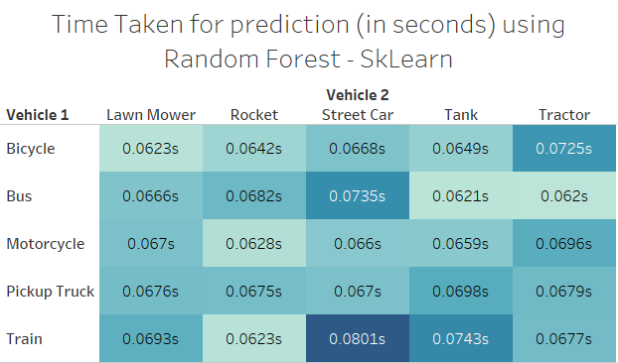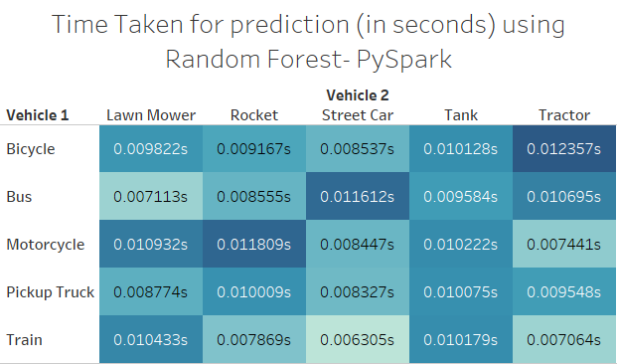

Figure 33: Matrix with prediction time- Random Forest

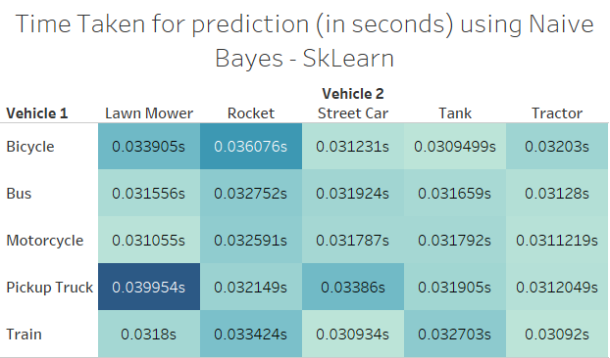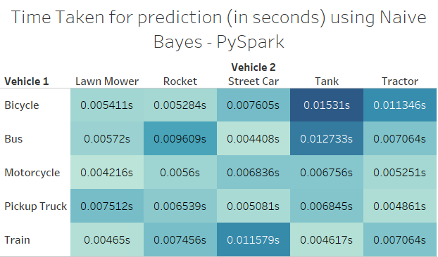

Figure 34: Matrix with prediction time- Naïve Bayes

The best pair is motorcycle (vehicle 1) and lawn_mower (vehicle 2) with accuracy of 70.10%

## **The output images**

**Milestone 1**

The output images show’s that 13 images (The red labels) are wrongly predicted and 23 images are correctly predicted using the random forest algorithm in Pyspark.

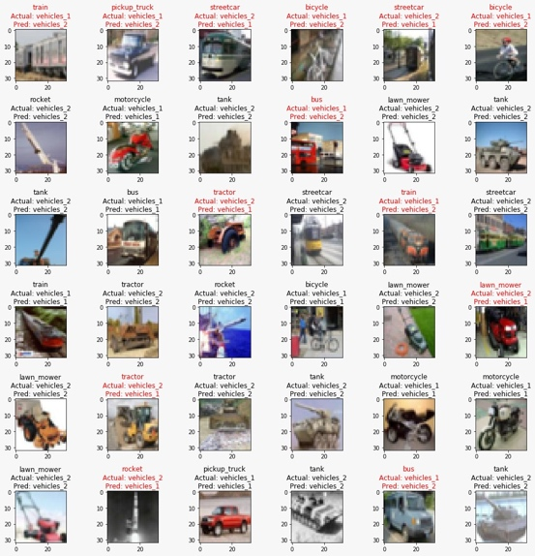

Figure 35: Output Images- Milestone 1

**Milestone 2**

From milestone 2 we see that the output image depicts that using the Random forest algorithm in pySpark, 11 images are wrongly predicted, and 25 images are predicted correctly.

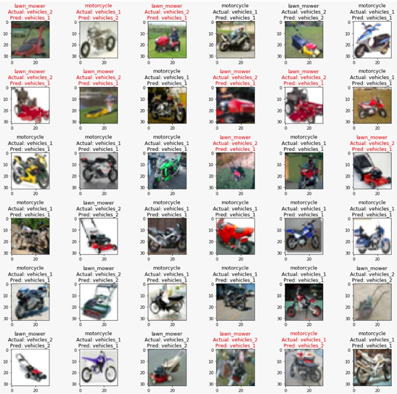

Figure 36: Output Images- Milestone 2

## **Descriptive Statistics**

**Milestone 2**

### **10.1 RandomForest**

**Sklearn**

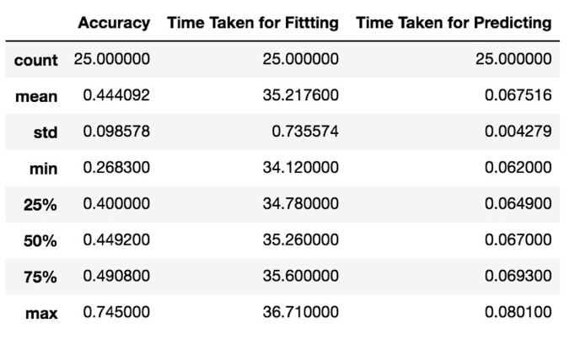

Figure 37- Descriptive Stats- RandomForest- Sklearn

**PySpark**

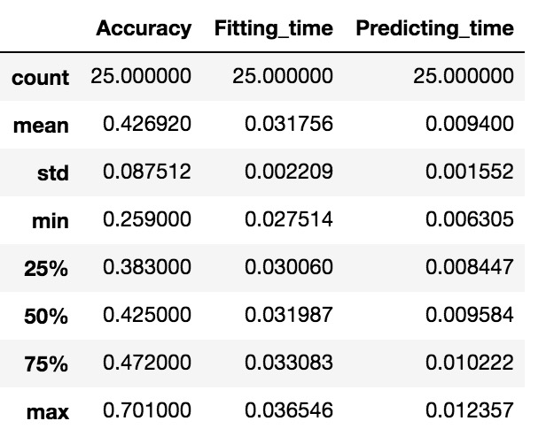

Figure 38: Descriptive Stats- Random Forest- Pyspark

### **10.2 Naïve Bayes**

**Sklearn**

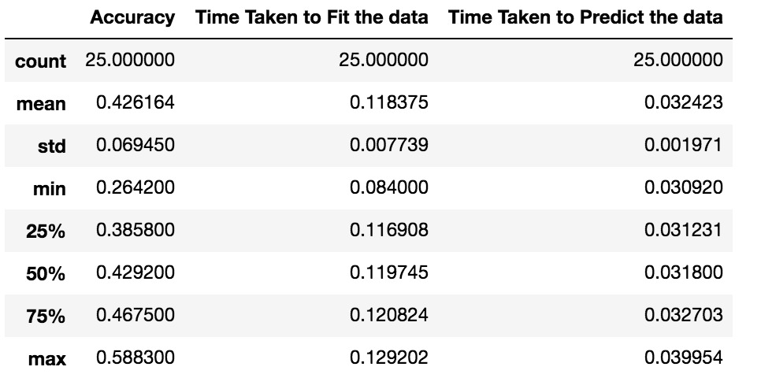

Figure 39: Descriptive Stats- Naïve Bayes- Sklearn

**PySpark**

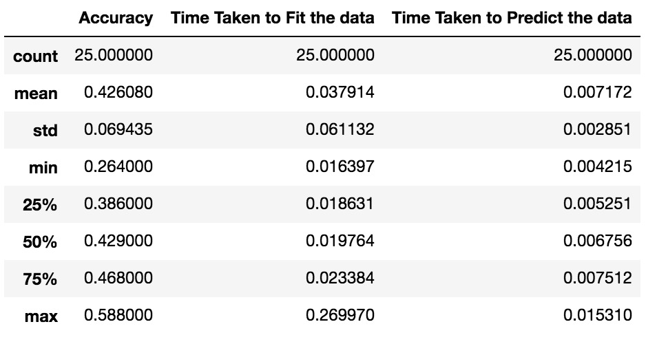

Figure 40: Descriptive Stats- Naïve Bayes- Pyspark

## **Model Comparison**

|  |  |  |
| --- | --- | --- |
| Scikit | ML1 CPU time(sec)  (RandomForest) | ML2 CPU time(sec)  (Naïve Bayes) |
| Average training time of 25 trials | 35.217600 | 0.118375 |
| Best Scikit CPU Time case | 36.710000 | 0.129202 |
| Worst Scikit CPU Time case | 34.120000 | 0.084000 |

Table 5: ScikitLearn training time comparison

|  |  |  |
| --- | --- | --- |
| PySpark | ML1 CPU time(sec)  (Random Forest) | ML2 CPU time(sec)  (Naïve Bayes) |
| Average training time of 25 trials | 0.031756 | 0.037914 |
| Best Spark CPU Time case | 0.036546 | 0.269970 |
| Worst Spark CPU Time case | 0.027514 | 0.016397 |

Table 6: PySpark training time comparison

|  |  |  |  |  |
| --- | --- | --- | --- | --- |
| Scikit | ML 1 accuracy  (Random Forest) | ML1 CPU time(sec)  (Random Forest) | ML 2 accuracy  (Naïve Bayes) | ML2 CPU time(sec)  (Naïve Bayes) |
| Average prediction time of 25 trials | 0.444092 | 0.067516 | 0.426164 | 0.032423 |
| Best Scikit CPU Time case | 0.745000 | 0.080100 | 0.588300 | 0.039954 |
| Worst Scikit CPU Time case | 0.268300 | 0.062000 | 0.264200 | 0.030920 |

Table 7: ScikitLearn prediction time comparison

|  |  |  |  |  |
| --- | --- | --- | --- | --- |
| PySpark | ML 1 accuracy  (Random Forest) | ML1 CPU time(sec)  (Random Forest) | ML 2 accuracy  (Naïve Bayes) | ML2 CPU time(sec)  (Naïve Bayes) |
| Average prediction time of 25 trials | 0.426920 | 0.009400 | 0.426080 | 0.007172 |
| Best Spark CPU Time case | 0.701000 | 0.012357 | 0.588000 | 0.015310 |
| Worst Spark CPU Time case | 0.259000 | 0.006305 | 0.264000 | 0.004215 |

Table 8: PySpark prediction time comparison

**Comparison between fitting time in PySpark and Sklearn**

**Random Forest**

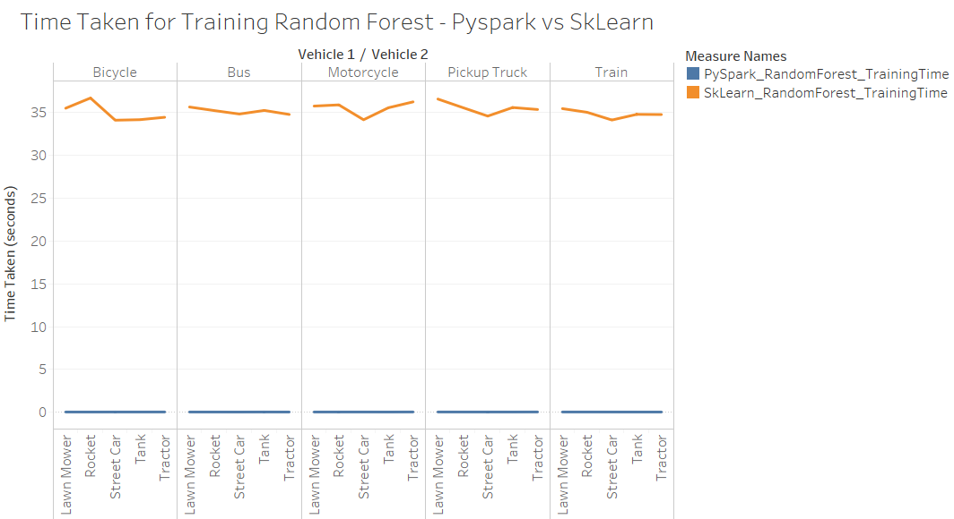

Figure 41: PySpark vs Sklearn- Fitting time – RandomForest

**Naïve Bayes**

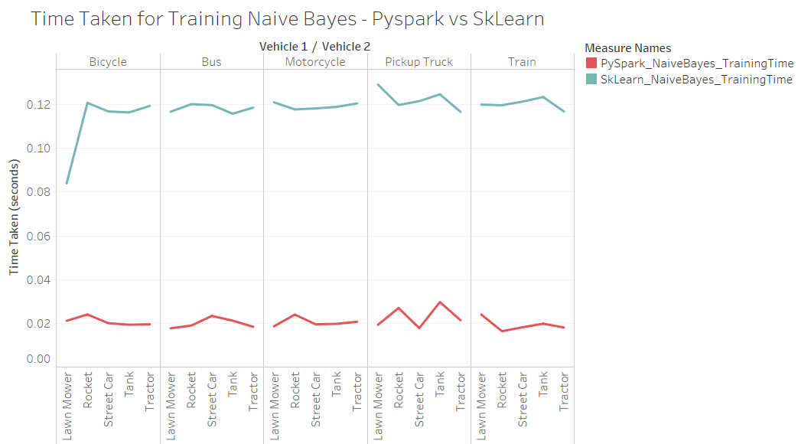

Figure 42: PySpark vs Sklearn-Fitting Time- Naïve Bayes

**Comparison Between prediction time Pyspark vs Sklearn.**

**RandomForest**

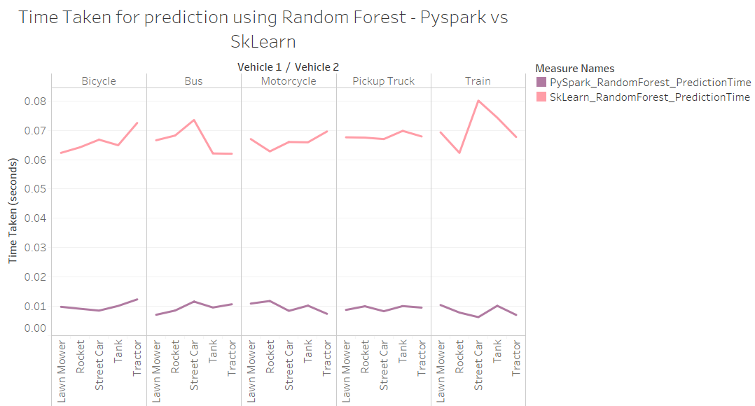

Figure 43: Prediction Time Comparison- RandomForest

**Naïve Bayes**

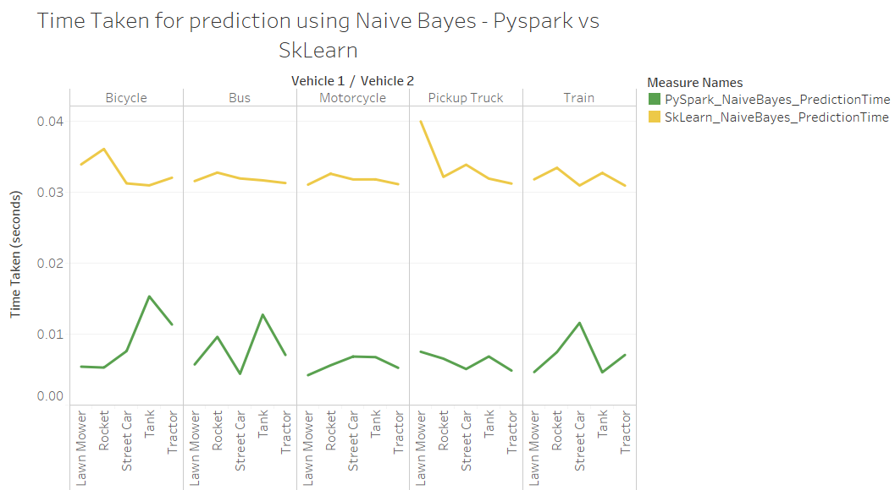

Figure 44: Prediction time Comparison- Naïve bayes

## **Additional Experiments**

**Milestone 1**

### **10.1 Normalizing**

Normalizing the data by dividing the data by 255 as the pixels could range till 255. This converted the data in the range 0 to 1. But , since we got similar results, we went ahead without normalization.

**Milestone 2**

### **10.3 Gray scaling**



Figure 45: Gray scaling

## **Conclusion**

Pyspark can handle big data. Computation matters as better configuration can lead to better results. Pyspark is able to handle traditional machine learning algorithms in Scala, Java and Python. Logistic, Naïve Bayes, Decision Tree algorithms and Random Forest were tried in PySpark and scikit-learn. RandomForest gave better and similar accuracy as in scikit-learn. MulticlassClassification Evaluator parameters of precision, recall resulted in accuracy evaluation. The time is calculated as CPU time for algorithms using PySpark and scikit-learn. Functions such as count(), show() take time to run in PySpark on the data input in the form of RDD. It is observed that in terms of fitting time on an average pySpark is 1000 times faster than Sklearn for Randomforest and 10 times faster for Naïve Bayes. The best pairs observed for the selected algorithm (RandomForest) are in Sklearn : lawn_mower- motorcycle, lawn_mower- pickup-truck, tank-motorcycle, tank-pickup truck, tractor-motorcycle. Worst pairs observed are in Sklearn: rocket-pickup truck, rocket-train, streetcar-bicycle, tank-bicycle, tractor-bicycle. Best pairs(RandomForest) in pySpark: lawn_mower-pickup truck, streetcar-bus, streetcar- pickup truck, tank-pickup truck. Worst pairs in (RandomForest)pySpark are rocket-pickup truck, rocket-train, streetcar-bicycle, tank-bicycle, tractor-bicycle.

## **Lessons Learned**

* Computation matters!-Pandas is not distributed processing whereas Spark is. Better hardware configuration, faster is the process.
* toPandas() is not scalable and its conversion from rdd is not directly feasible.
* Mlib vs ML- ML uses dataframe whereas Mlib uses RDD. Mlib contains the legacy API.
* randomSplit using for test-train does not split in exact count of 80:20 out of the total.
* Optimize code- to have few action statements at the end is a good practice.
* BinaryclassClassification Evaluator vs MulticlassClassification Evaluator-BinaryclassClassification has areaunderROC and areaunderPR metric whereas
* MulticlassClassification has metrics like precision, recall, accuracy.
* Normalization and Image Gray scaling affects performance of the model
* PySpark is faster in terms of CPU time. However, slower in terms of wall time.

# **References**

|  |  |
| --- | --- |
| [1] | "CIFAR 100 DATASET," [Online]. Available: https://www.cs.toronto.edu/~kriz/cifar.html. |
| [2] | "Google Colaboratory introduction – Learn how to build deep learning systems in Google Colaboratory," [Online]. Available: https://adventuresinmachinelearning.com/introduction-to-google-colaboratory/. |
| [3] | V. Ruusmann, "R, Scikit-Learn and Apache Spark ML - What difference does it make?," [Online]. Available: https://www.slideshare.net/VilluRuusmann/r-scikitlearn-and-apache-spark-ml-what-difference-does-it-make. |
| [4] | " Ensembles - RDD-based API," [Online]. Available: https://spark.apache.org/docs/2.1.0/mllib-ensembles.html#random-forests. |
| [5] | R. Chapman, "Operationalizing scikit-learn machine learning model under Apache Spark," [Online]. Available: https://quickbooks-engineering.intuit.com/operationalizing-scikit-learn-machine-learning-model-under-apache-spark-b009fb6b6c45. |
| [6] | "mllib naive bayes," [Online]. Available: https://spark.apache.org/docs/1.5.1/mllib-naive-bayes.html. |
| [7] | "difference-between-bernoulli-and-multinomial-naive-bayes," [Online]. Available: https://datascience.stackexchange.com/questions/27624/difference-between-bernoulli-and-multinomial-naive-bayes. |